BALUSTER COLLABORATION
with Tamara Nic Coscair and Vivienne Dick

IMMA residency X IOMV Linen Hall/Dublin UNESCO City of Lit cross-border programme
“Museum both as a physical space and as a subject.” Pushing “institutional/ political/ geographical boundaries” in a “layered, time-collapsing narrative.” IMMA as “a radically public space.”

Starting point is an early 19th-century Roman cement baluster from the original site, kept in storage since the 1990s beneath the restored IMMA balustrade in the gardens —> Tamara initially encountered exportation restrictions when trying to bring the baluster to the North of Ireland at The Linen Hall. She later gained necessary permissions to possibly export the artefact within Europe.



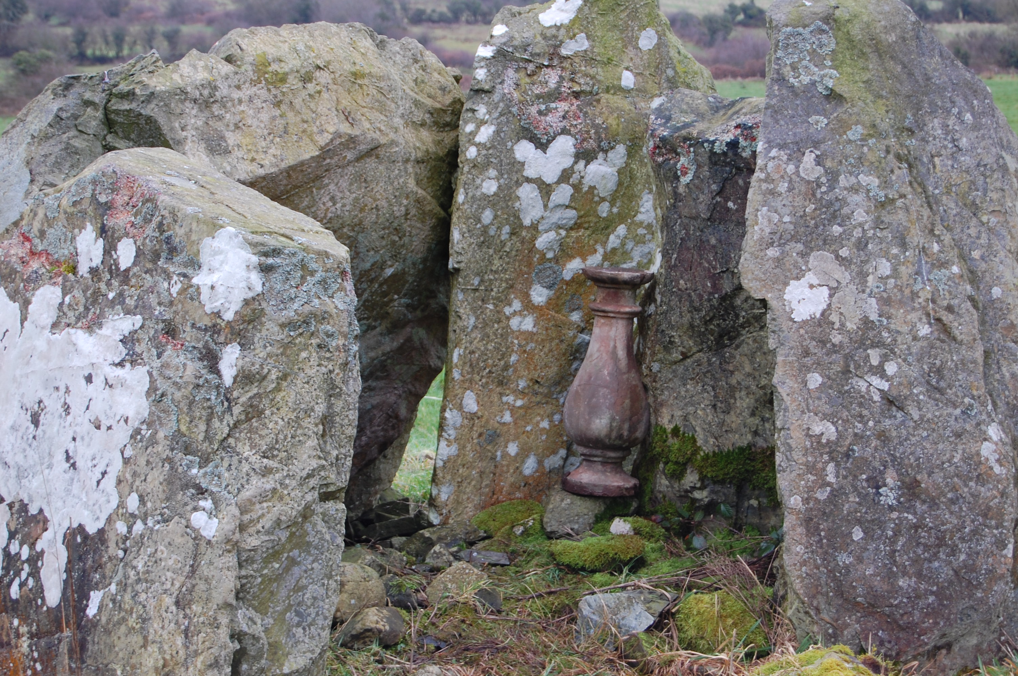
Tamara filmed Vivienne Dick in a subversion of roles, “performing the gesture of mobilising the baluster” in a streetscape in Inchicore. She also carried it to feminist protests in Belfast and Dublin.

Poetic response from Jo Morrigan Black:
My concrete poem responds simultaneously to the baluster’s trajectory through time, as well as to the
Linen Hall’s Divided Society digital collection, seeking to push the limits of materiality across temporal and physical borders. As a poet, I specifically borrowed from written artefacts in the collection, excavating a selection of material objects mentioned in news articles, posters, poems, crosswords, arts reviews and advertisements, in order to playfully invite these material objects and their contexts into an intertextual, cross-border conversation with the baluster. The first spoken performance of my poetic response will take place within the walls of the archive at The Linen Hall, on March 20th 2026, collapsing time in a collective encounter and marking a point of convergence between The Linen Hall’s past (the archives), its present (the Island Of Many Voices programme) and its future (the archives’ poetic mobility across borders with the touring exhibit in development).

Poetic Research
Selected artefacts from The Linen Hall’s digital collection:
“Divided Society Northern Ireland 1990-1998”

Maighread Medbh, “Women’s Words, Easter 1989” in Women’s News #45 — DEC. 1989/JAN. 1990
POEM: “The proud Republic they cried and died for is a turncoat bastard picking their pockets by the side of a new main road, heading south.” {pocket} {new main road}

Mark Brennock, “Power to these people?” in Fortnight #292 — FEB. 1991
ARTICLE on Belfast City Council and the Northern Ireland Office: “the man on the balcony” “that dreaded hyphenated word—power-sharing—will be the order of the day” {balcony}

Floyd King, “Review: Shoot the women first” in Irish Freedom #16 — AUTUMN 1991.
BOOK REVIEW of Eileen MacDonald: “carrying bombs in their handbags and so on” {handbag}

Imelda Foley, “Review: Observing the watched” in Fortnight #309 — SEPT. 1992
THEATRE REVIEW of Frank McGuinness’s play, Someone Who’ll Watch Over Me at Hampstead Theatre, London: “The final image of Eddie dressing for liberation in brand new clothes (…) asks another question. The funeral clothes (…) [suggest] that Eddie himself is facing not a new life, but a kind of living death.” “He asks that living reality rather than history be faced, in order to begin to find answers to old problems which have contemporary life.” {funeral clothes}

Jim Dee, “Ian Paisley JR Interview” in Northern Ireland Report #7-8 — NOV. 1992
INTERVIEW with the DUP’s Ian Paisley: “Now we don’t want to restrict people’s movement, but I would willingly forgo a couple of civil rights (…) for the sake of helping stop terrorism.” “At the moment you have a Ring of Steel around the centre of Belfast - you can’t go into the centre of Belfast without being searched. That’s useless! You don’t block the economic arteries of the community. You block the arteries of the areas where the bombs are being made.” {steel}
Action Group for Irish Youth, “Thousands are sailing…What crisis?” in AGIY-INFO The challenge now: review '92 — DEC. 1992
“a new wave of contemporary emigration from Ireland” “In the period 1985-1990 it is estimated that a total of 113,700 people left N. Ireland representing approx 7% of the population” {wave}

Judith Hill, “Subversive: Feature Art” in Fortnight #318 — JUNE 1993
ARTICLE covering four years of council permission refusal for the 'Monument to the Unknown Woman Worker' by Louise Walsh in front of Belfast Europa Hotel, Great Victoria Street: “the hand simultaneously comforts and propels” “baby’s dummies (…) telephone-elbow (…) typewriter-stomach” {typewriter-stomach}

Mary Collins, “In Ireland… Travellers” in Workers Solidarity #39 — JUNE 1993
ARTICLE covering racist attacks against Travellers and protests following the violent eviction of nine families in Clondalkin on May 20th, 1993: “slurry against caravans” “Some notorious schools have gone so far as to paint a white line down the middle of the playground and Traveller children are not allowed to cross over it.” “The eviction party arrived at 8:30am. They refused to give families time to move their possessions or even get their children out of bed.” {line} {paint} {bed}

Barney Boswell Sinn Fein Cumann, “Jigsaw” in Nuacht an Iúir #65 — JULY 1993
NEWSLETTER: “What the archaeologists didn’t reveal is that nearby they found a sundial with the inscription “Don't let the dinosaurs get you down”.” {sundial}

Cora Baker, “Creativity or Theatrical Terrorism?” in Fingerpost Monthly #6 nº3 — AUG./SEPT. 1993
THEATRE REVIEW of Druid’s Derry performance of At the Black Pig’s Dyke by Vincent Woods, disrupted in protest by Ad Hoc, who infiltrated the group of mummers at the end of the play: “Then removing the mummer’s mask, he revealed a Union Jack, wrapped mercilessly round his head, wielded a cleaver, a butcher-mummer costume, and a script which didn’t improve on “At The Black Pig’s Dyke”. It is little wonder that the cast were terrified and fled the stage. He was lit by a spotlight hand-held by someone in the front row of the audience. When the Union Jack was removed, a clown like that of Tom Fool, a character in the play, was revealed: “Who’s fooling who?”” {cleaver}

Roy McFadden, “Another Place” in Fortnight #330 — JULY/AUG. 1994
POEM: “Whose frontiers confiscate appearances, / Where passports are what’s scripted in the hand, (…) While clocks below the watchful balustrade / Cried out like birds against imagined dawns”
{watchful balustrade}

Cathal O Searcaigh, “Geasa” in Fortnight #330 — JULY/AUG. 1994
POEM set in a garden: “Mé easnamhach ar an uaigneas measc cloch / gan seasamh san uaigneas measc cloch” {in the loneliness among stones}

Ruth, “Kissin' & huggin' & marchin' & cruisin' & rockin' & rollin' & drinkin' & floozin' ...” in Women’s News #70 — SEPT./OCT. 1994
ANONYMOUS ARTICLE on Belfast Pride ’94: “The open top bus that whisked us back to a buffet in the Orpheus was a hoot, as usual.” “The scene was a blurred mish-mash of sequins and Elvis buckle-belts and frightful wigs.” {open top bus} {frightful wigs}

Royal Ulster Constabulary Police Federation for Northern Ireland, “Two-In-One Crossword” in Police Beat #17 nº1 — JAN. 1995
CROSSWORD: “Down 2. Raven had fluttered about on the balcony (8)” Solution: “Verandah” {raven} {on the balcony}

“Call for re-naming of flats” in Irish Republican Information Service #May 8, 1995
ANONYMOUS ARTICLE about Europe Day protest demanding the re-naming of Belfast social housing: “The 42-ft banner read “We serve neither King nor Kaiser but Ireland” and was displayed on the top balcony of the Churchill House tower block.” “The most popular alternative being discussed is that the tower blocks be named after Belfast rivers and hills or Irish saints.” {balcony} {name}

Hewitt’s Menswear Ltd., Armagh, “Regalia” in The Orange Standard #May 1995
ADVERTISEMENT featured next to an Easter march photographic report, focused on Apprentice Boys: “Also aprons, cuffs, ties and emblems.” “Quality products — keen prices.” {keen prices}

John O’Farrell, “Moving and Shaking” in Fortnight #341 — JULY/AUG. 1995
ARTICLE on the Reconciliation and Community conference in Belfast Europa Hotel: “hectic hand gestures indicated that it was time for the terrible two to descend the stairs and into history.” [Michael Ancram and Gerry Adams] “(…) if not quite making friends, then maybe losing enemies.”
{descend the stairs and into history}

“Women Together: Christmas Campaign” Anti-Sectarian Poster — 1995
POSTER featuring a printed illustration of a candle lit over branches of fir and holly: “(…) spare a thought or a prayer for the families facing this festive season without a loved one, a victim of sectarian violence.” {candle}

Niamh O’Connor, “All aboard the Garda bus” in The Big Issues #42 — MAY 1996
ARTICLE on the Garda Community Relations Bus, interviewing service users, including Elizabeth Furlong, who grew up in the Liberties in the 1940s: “We could leave the flat doors open (…) A gang of us kids would sit on the stairs of the flats in Bride Street eating a cut of bread with sugar on it. (…) We’d hold on for dear lives to each others’ frocks as we climbed up the stairs in the pitch dark. (…) On Sundays the men went to the bird market and bought finches and songbirds and put them into brown paper bags.” {stairs in the pitch dark} {finches and songbirds in brown paper bags}

Patrick J. O'Leary, “Ireland's historic struggles are still vivid for 90 year old Nora McKenna” in The American Gael #17 nº4 — OCT.-DEC. 1996
ARTICLE interviewing Connecticut resident Nora McKenna about her Kerry childhood during the Irish War of Independence, including sharing a cell in Kilmainham Gaol with Grace Gifford Plunkett: ““I can still see that awful exercise yard where the sun never shone over the 40-foot walls (…) I often walked with Grace in that yard. (…) She painted a very beautiful mural of the Blessed Mother on the whitewashed wall of her cell.”” “May the sod lie softly on their graves.” {sun} {wall} {paint} {grave}

Laura Friel, “Sinn Féin Enter Talks” in Australian Aid for Ireland #8a vol. 3 — SEPT. 1997
ARTICLE from An Phoblacht on Sinn Féin gaining entry into the Stormont talks: ““The business of peace is the business of justice”, [Gerry Adams] said. “I am disappointed that there are some empty chairs. (…) I would like all the people of this island to take possession of it. They have a vested interest in a lasting peace and the issues involved are too important to be left to the people in this room.”” {empty chairs}

Karine Guerin, “Why Are You Here?” in The Big Issues #88 — FEB. 1998
ARTICLE linked to the publication’s “on going campaign to fight growing racism in Ireland”, interviewing four people waiting to obtain refugee status, including an “Algerian civil servant”: “He has managed to find a room he describes as being “very small, with no hot water and a dirty shower shared between the whole building” but he doesn’t mind as it is a refuge for his peace of mind.” ““Today I’m not working, I feel I’m not a man anymore. I don’t know what is going to happen to me tomorrow.”” {room}

Poem title: HOW TO SMUGGLE IRELAND INTO IRELAND

Too heavy to carry up the new main road
in a handbag or a pocket of our own
we did not float it down the waves
strapped to algae or ice in
the loneliness among
stones. A shadow too
wounded to be shown
we did not steal it from the balcony
nor rouse it from its dark repose
beneath the stairs; repeating
history of shrouded steps
funeral clothes on empty
chairs, the quiet line, our
sleeper on the straw. The
sun never left the garden
lest to visit its grave. We
did not seek to veil it from
the painter in the gaol, nor
lease it to the feathered hand
of the worksite crane, nested into
concrete. All too still for our unrest
we could not bargain a keen price, nor
did we learn to walk with it through walls
bound flat to our chests. We could not cradle it
in crowds, where the many voices sang, nor could
we swallow its name in the pitch dark, punched into
typewriter-stomachs, steel caught in our throats. Slow to lose our enemies, we did not board the open top bus
in frightful wigs alone; together, held the shadow of the
flame, looked close beyond the keyhole to the cold blame
still, gathered, laughing at its wake, we did not heed a
sky divided from the missing dawn. Before our eyes
the shadow landed, fleet-footed in its shrine
the raven on the watchful balustrade
soaring out of time; the gossip
stone, the empty womb, the caw
we could not trade the candle
for the cleaver; the
new day had no room to loan
too costly to be smuggled back with
finches and songbirds in brown paper bags
feather-light, we lowered it, a sundial on the roadside
in public view; fractured time, too old to know a home.
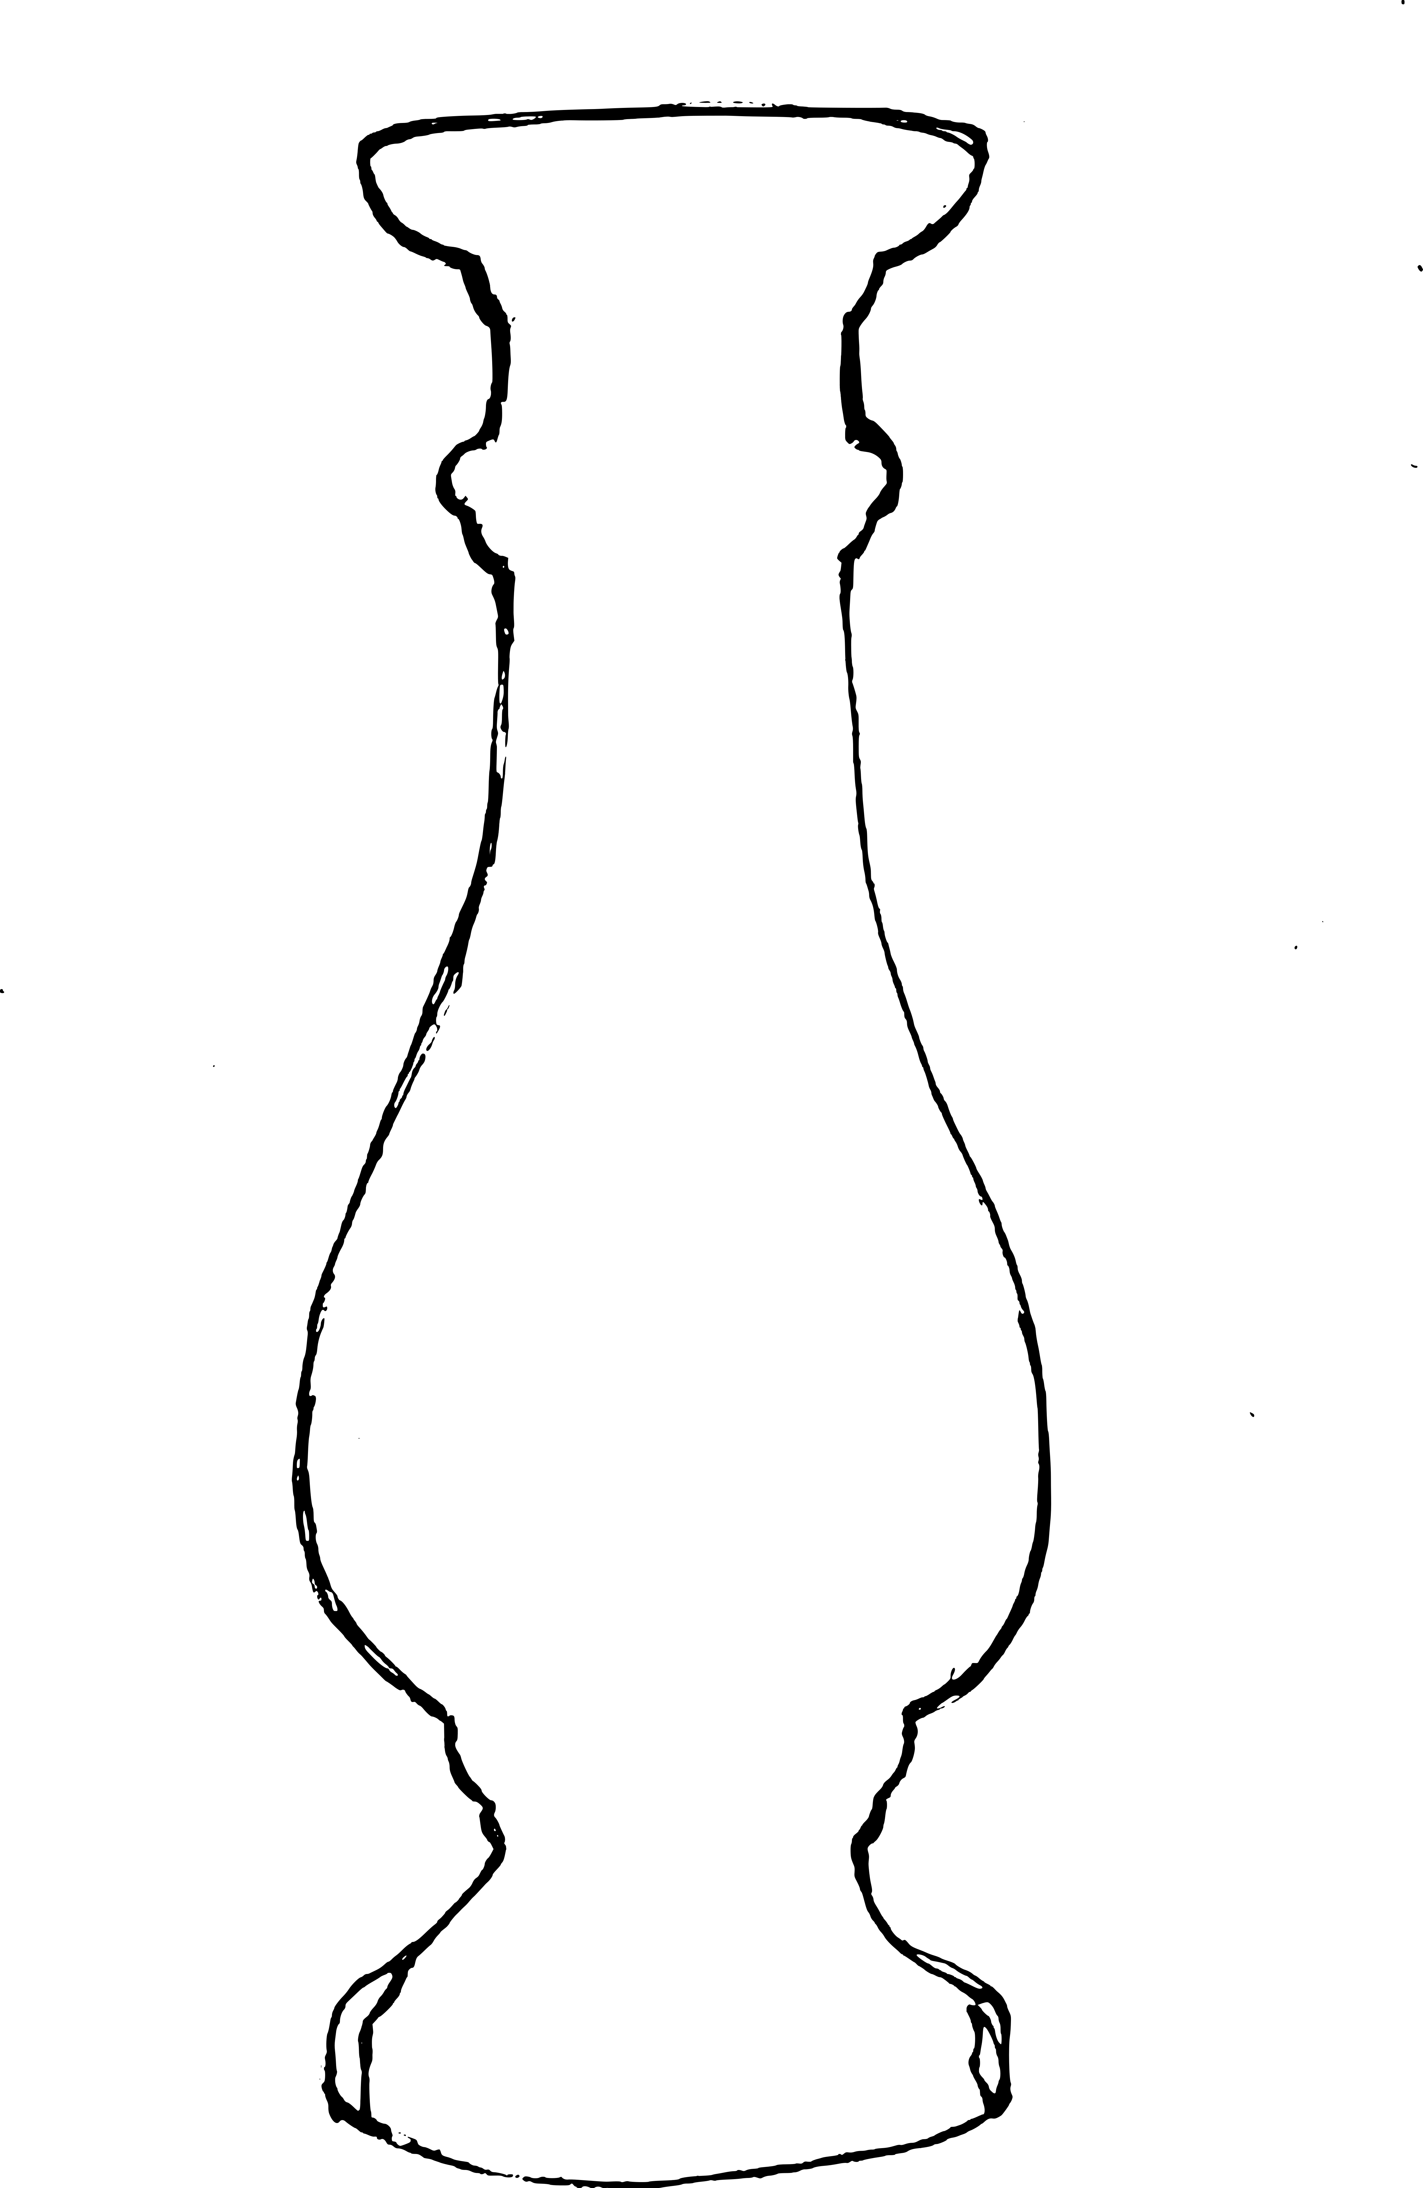

HOW
TO
SMUGGLE
IRELAND
INTO
IRELAND

